App in a Day

Hands-on Lab Step-by-Step

Contents

Complete Solution 1

Task 1: Create a new environment 1

Task 2: Import the solution 3

# Complete Solution

Follow the steps below to see the complete solution without completing the modules

## Task 1: Create a new environment

1. Open a new browser tab, navigate to [Power Apps admin portal](https://admin.powerplatform.microsoft.com/) select **Environments** and click **New Environment**.

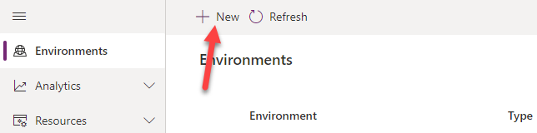

1. Provide an **Environment Name**, select **Trial** for **Type**, select **Region**, select **Yes**, for **Create** a database, and click **Next**.

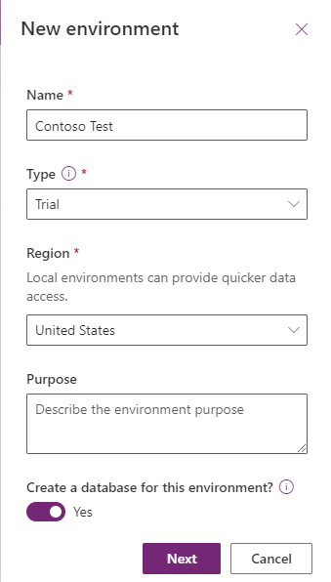

1. Select **Language, URL,** and **Currency**. Choose **Yes** for **Deploy sample apps** **and data** and then click **Save**.

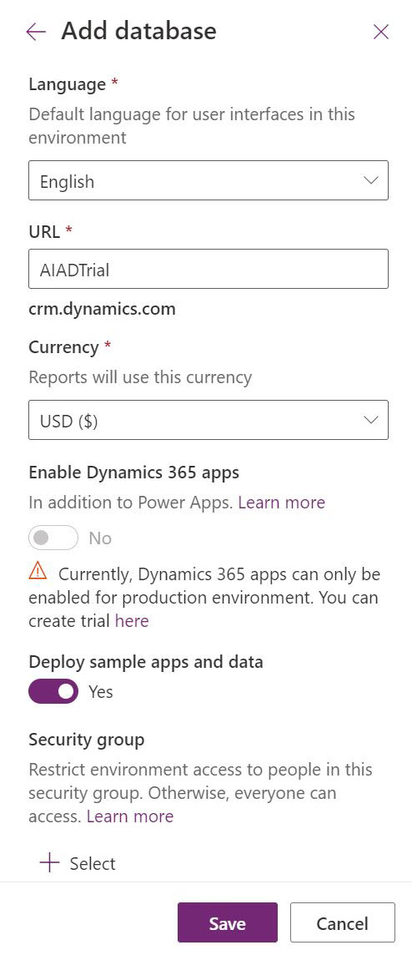

1. Wait for the environment to be created.

## Task 2: Import the solution

In this task, you will import the completed module 4 solution.

1. Navigate to [Power Apps maker portal](https://make.powerapps.com/)
2. Make sure you are in the **Contoso Test** Environment you created.
3. Select **Solutions.**

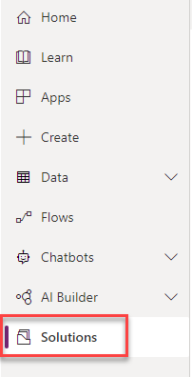

1. Click **Import**.

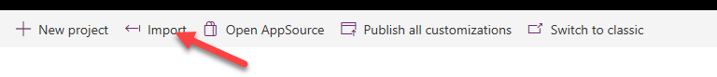

1. Click **Browse**.

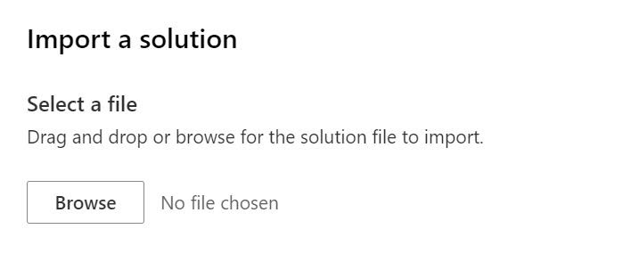

1. Select the **Contoso Coffee** solution zip file located in Module 4 Completed folder and click **Open**.
2. Click **Next**.
3. Click **Next** again.
4. Click on the connection dropdown for the **Microsoft Teams** connector and select **+ New connection**.

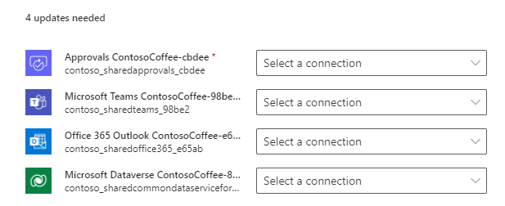

1. Click **Create**.

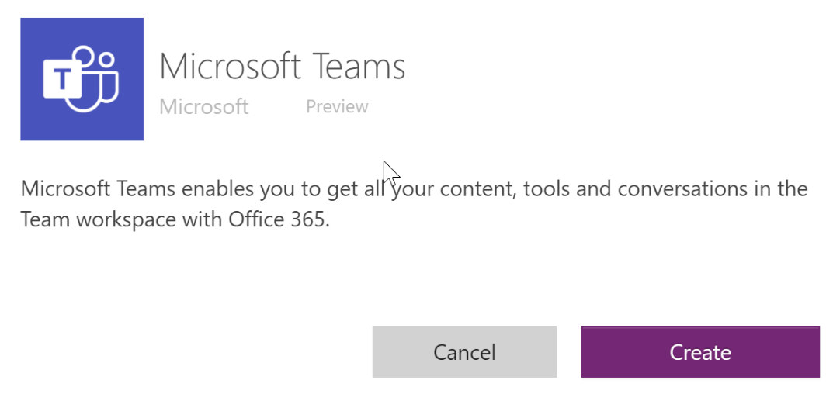

1. Select your credentials.
2. You should now have one connection listed. Close the connections browser tab or window.
3. Click **Refresh**.

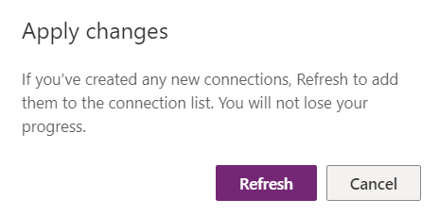

1. The connection you added should get selected. Follow the same steps to add the rest of the connection.
2. Add the connections and click **Import**.

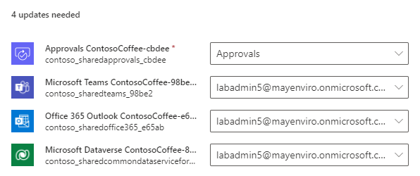

1. Wait for the solution import to complete.
2. Once the import is complete, Click **Publish All Customizations** and wait for the publishing to complete.

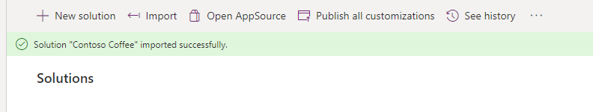

1. Select **Apps** and launch the **Machine Ordering App.**



1. Click **Allow**.
2. Select few machines and click **Compare**.

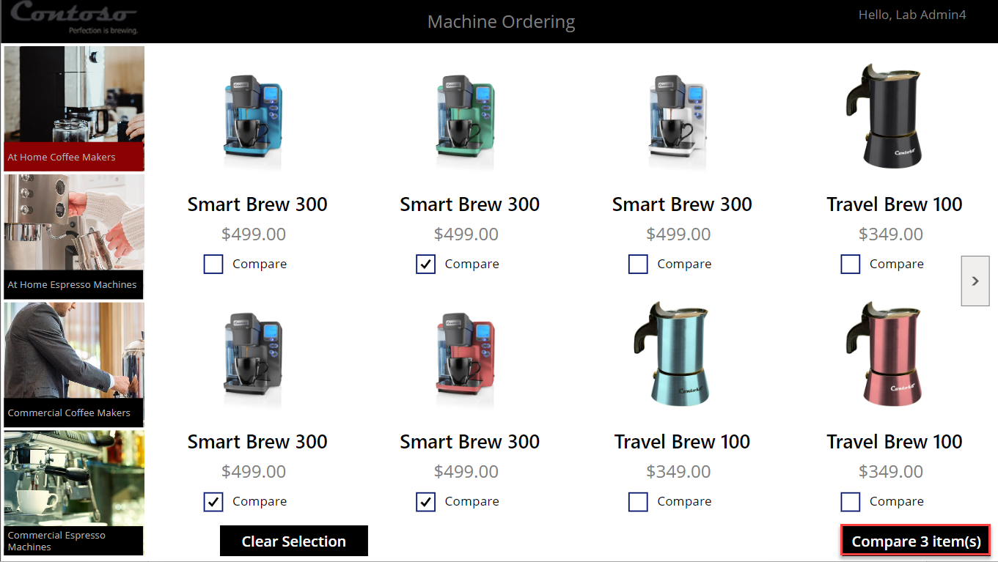

1. Select one of the machines and click **Submit**.

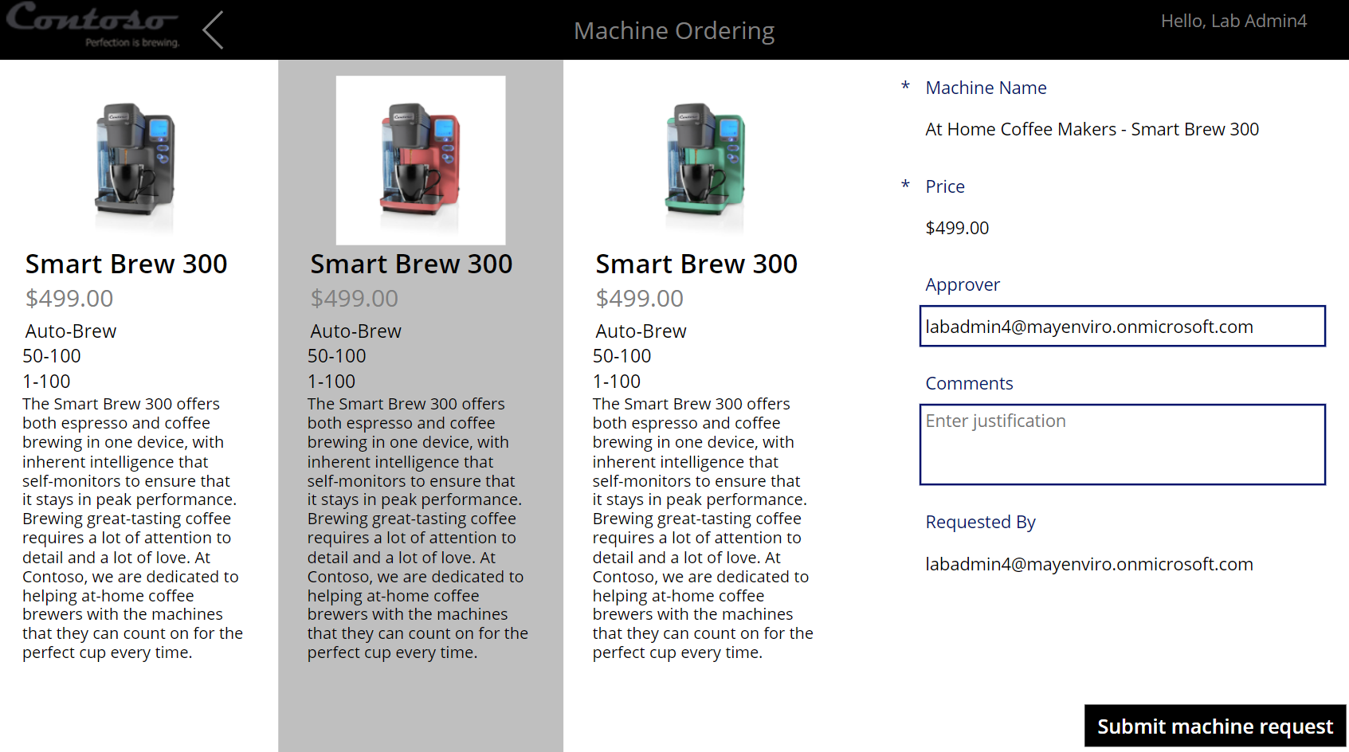

1. Click **OK**.
2. Close the application by simply closing the browser tab.
3. Select **Apps** and launch the **Machine Procurement** application.

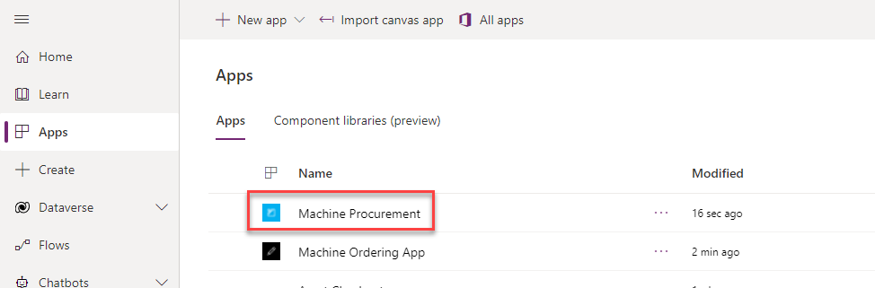

1. Click to open the record you created in the last task.

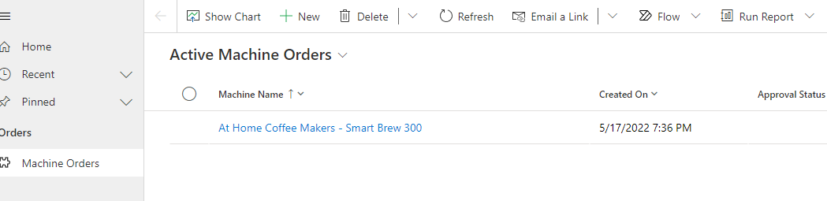

1. The record should open, and you should see a business process flow.

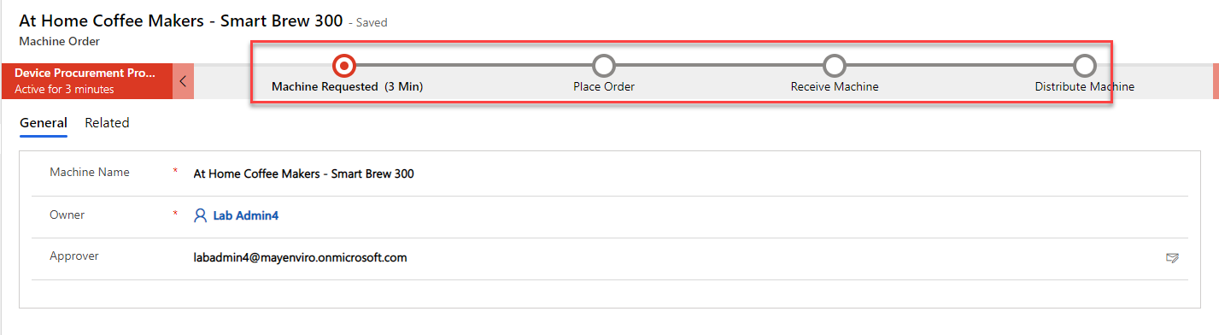

1. Close the Model-driven application browser window or tab.
2. Select **Solutions** and open the solution you imported.
3. Select Cloud flows and you should see **New machine approval request** flow.

